Shark adaptations
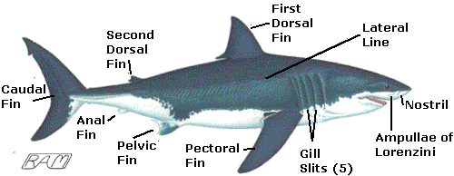

Size
Among the very largest of sharks, the Great White regularly reaches a length of 6 metres and a weight of more than two tons. This makes the Great White powerful enough to catch prey.

Colour
The Great White is dark above and white below. This makes the Great White difficult to see. Pacific Coast Great Whites tend to be very dark above. This darkness helps camouflage the Great White against the dark, rocky bottom over which it typically swims.

Skin
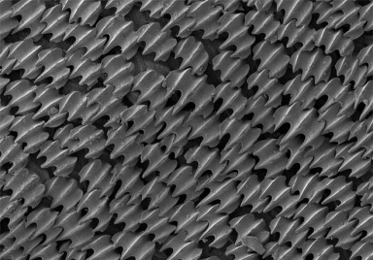
Like other sharks, the skin of a Great White is very tough and studded with tiny, tooth-like scales called "dermal denticles". Dermal denticles protect the skin from damage and are replaced continually. Each individual denticle has a flat, table-like crown that has a series of raised ridges. These ridges reduce the drag and noise generated by a shark's swimming movements, enabling the Great White to glide efficiently in ghost-like silence.

Jaws
As in other sharks, the upper jaw of a Great White is not fused to the skull. This arrangement allows a Great White to protrude its jaws outward from the head, extending the reach of its teeth and creating a partial vacuum that helps suck in prey.
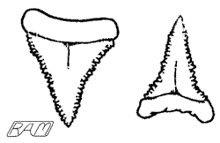 | Teeth  The teeth of a Great White have broadly triangular blades with coarsely serrated edges. The upper teeth are broader and flatter than the lower teeth, which reflect their different roles during biting. The lower teeth stab into and hold secure a food item while the saw-like upper teeth gouge out a hunk of flesh. This dental arrangement allows the Great White to feed on prey too large to swallow whole as well as scoop calorie-rich blubber from whale carcasses.

Eyes
The eyes of a Great White are large and well developed and can see in colour.

Nostrils
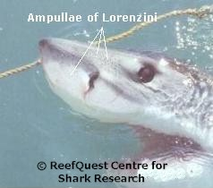
Each nostril of a Great White consists of a flap of skin that controls water movement into a cup-like structure. The cup-like structure contains a roughly spherical scent-detecting organ called an "olfactory bulb". Each olfactory bulb is composed of a series of closely-packed plates of tissue that are extremely sensitive to dissolved chemicals. The Great White has the largest olfactory bulbs of any shark species measured to date, enabling it to locate bleeding prey, decomposing whale carcasses, and seal or sea lion colonies by their distinctive odours.

Electroreceptors
Like other sharks, the Great White has specialized sensory organs that detect extremely minute electrical fields. These organs are called "ampullae of Lorenzini". The Great White uses these electroreceptors to locate hidden prey.

Fins
Like other sharks, the Great White has paired and unpaired fins. The pectoral and pelvic fins are paired, while the first dorsal, second dorsal, anal and caudal (tail) fins are unpaired. The pectoral fins control banking, turning, ascending, descending and breaking as well as acting as important signalling structures. The first dorsal fin is important in preventing unwanted roll, keeping the shark on an even trim. The caudal fin is the main propulsive structure, featuring an efficient crescent shape and supported on either side by sturdy keels. All these fins allow the Great White to finely control its movement through the water.

