**C:\Users\Alice\AppData\Local\Microsoft\Windows\Temporary Internet Files\Content.IE5\6P6YJYHV\MC900057449[1].wmfExperiment – Penguin huddle**

**Aim:** To investigate huddling as an adaptation

**Equipment:** 2 large beakers, 6 small test tubes, 2 thermometers of data loggers with temperature probes, hot water, 1 rubber band, stopwatch (if you are using thermometers and not data loggers)

**Method:**

1. Use a rubber band to tie 5 test tubes together.
2. 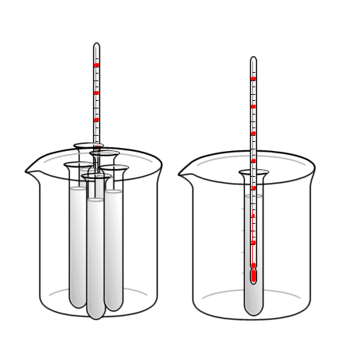Place the 5 test tubes in a beaker. This is like 5 penguins huddling.
3. Place one test tube by itself in the other beaker. This is like a penguin by itself.
4. Pour equal amounts of hot water in each test tube.
5. Put a thermometer in the middle test tube of the 5 test tubes. Put another thermometer in the test tube by itself.
6. Measure the temperature of both thermometers every minute for 10 minutes.

**Results:**

|  |  |  |  |  |  |  |  |  |  |  |
| --- | --- | --- | --- | --- | --- | --- | --- | --- | --- | --- |
| Time (minutes) | 1 | 2 | 3 | 4 | 5 | 6 | 7 | 8 | 9 | 10 |
| Temperature of middle test tube (°C) |  |  |  |  |  |  |  |  |  |  |
| Temperature of test tube by itself (°C) |  |  |  |  |  |  |  |  |  |  |

Graph your table of results on the next page.



**Discussion**

1. Describe what your results show by referring to the table and/or graph.

__________________________________________________________________________________________________________________________________________________________________

1. What is an adaptation?

_________________________________________________________________________________

1. Do you think the act of penguins huddling together is an adaptation? Why or why not? Refer to your results.

____________________________________________________________________________________________________________________________________________________________________________________________________________________________________________________________________________________________________________________________________

**Conclusion:**

_____________________________________________________________________________________________________________________________________________________________________________________________________________________________________________________________________