Comparing how well metals and non-metals conduct electricity and heat
Experiment 1 - How well do metals and non-metals conduct electricity?
Metals conduct electricity well while non-metals do not.
What to do
- Set up the transformer, light globe and wires like the diagram below. Make sure the wires are connected to DC and the voltage is not past C or 6 volts.

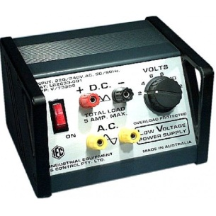

Object being tested

- Connect different objects to complete the circuit. If the light glows it means that object conducts electricity well. If the object doesn’t light up the light globe, it means the object doesn’t conduct electricity well.
- Make a table in your book or on your device to record the results. You can also take a photo of each of your results with your device.
Object name | Did the light globe glow? (Yes or No) | Does this object conduct electricity well? (Yes or No) | Is the object a metal or non-metal

Experiment 2 - How well do metals and non-metals conduct heat?
Metals conduct heat better than non-metals. This means that heat can pass through metals faster than non-metals. Metals are known as conductors while non-metals are known as insulators.
What to do
- Fill a beaker with hot water.
- Place a metal spoon and a wooden paddle pop stick into the hot water.
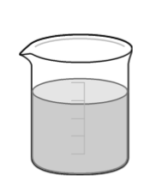
- Wait 5 minutes.
- Touch the top of the metal spoon and the paddle pop stick and decide which one is hotter. Write your results in your book or on your device.

Example:
The ______________ was hotter because it is a ____________________ and lets heat travel through it faster.

- You can also take a photo of each of your results with your device.

